Somerset Youth and Community Service

**Keeping children and young people safe:**

**A guide for organisations**

**Abuse can happen anywhere, but we can all help our children and young people stay safe**

**Introduction**

This booklet is aimed at staff and volunteers who run youth clubs, and provides clear guidelines to help keep young people safe. It will alert you to issues of child abuse generally and guide you through the steps required if any form of abuse is discovered.

**Somerset Youth & Community Service**

The Hollies, South Street, Taunton, TA1 3AG

01823 357552

youthservice@somerset.gov.uk

www.somersetyouth.co.uk



**Creating a safer environment**

We all want to reduce and prevent incidents of child abuse and protect young people in youth club settings from:

1. An offender or potential offender in the club
2. An offender or potential offender who may, in future, attempt to gain access to the club, and
3. An offender or abuser outside the club, who may be abusing a child or young person

This booklet can help achieve aims 1 and 2 by education and informing people who run the club about good practice, and 3 can be achieved by raising levels of awareness of volunteers, parents, carers, staff and managers. Alongside raising young people’s self-esteem, the ability to spot abuse will help you manage your club safely.

For information about types of abuse, the signs to look for and what to do if you suspect or are told about abuse, please see page 11.

The first thing is to have the right policies and procedures. Your club needs:

* + - * A child protection or safeguarding policy
      * A staff vetting policy
      * At least one appointed safeguarding officer
      * A code of conduct for staff and volunteers
      * Everyone to have good awareness of health and safety procedures
      * A rigorous staff and volunteer selection and management process
      * A way to let parents know what you’re doing

Somerset Youth and Community Service has many sample documents that you can adopt, and provides advice and information about making your club safer.

**Becoming a safer organisation**

**Developing policies**

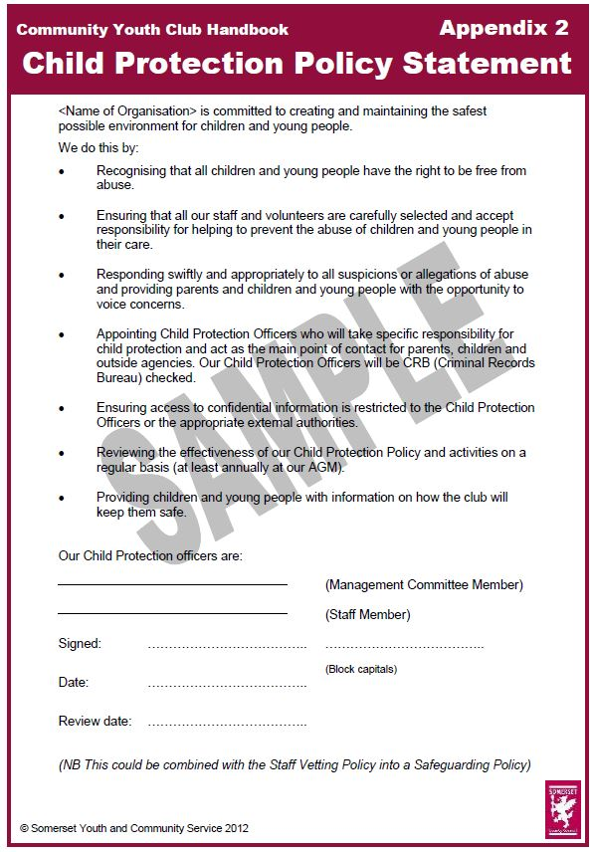The first step to creating a safer environment for young people in your organisation is to adopt formal Child Protection/Safeguarding, Staff Vetting, Health and Safety, Risk Assessment and Equalities policies. Somerset Youth and Community Service (SYCS) has useful free samples of all of these.

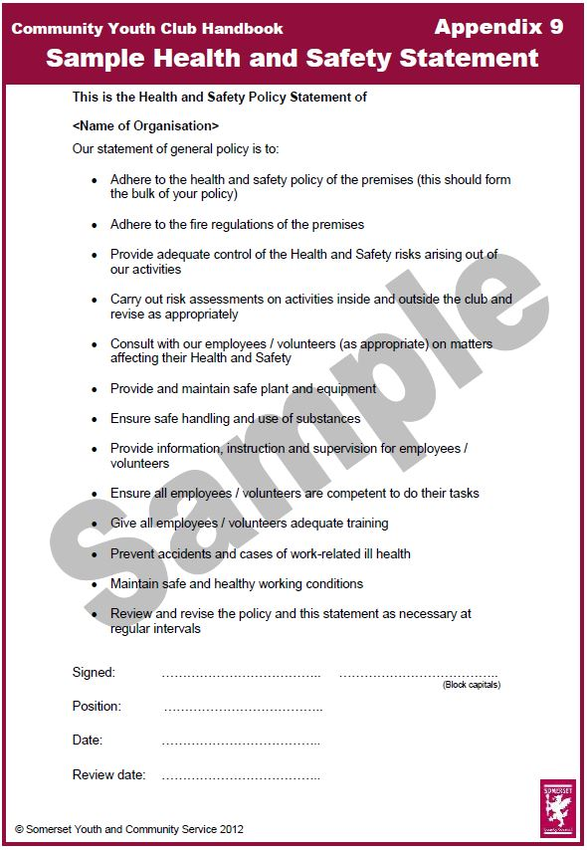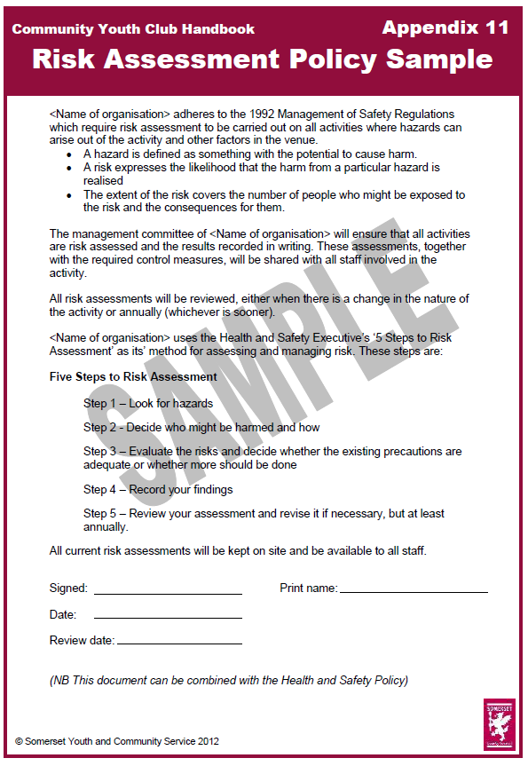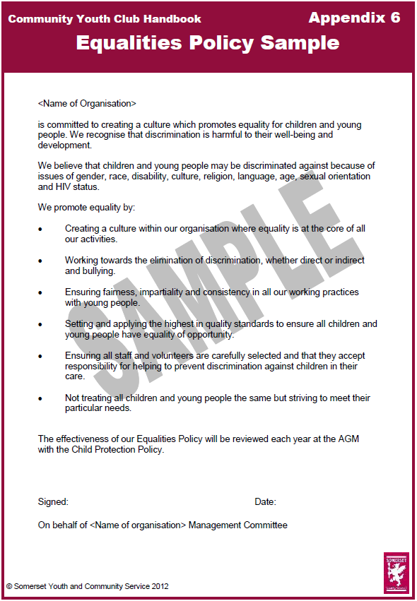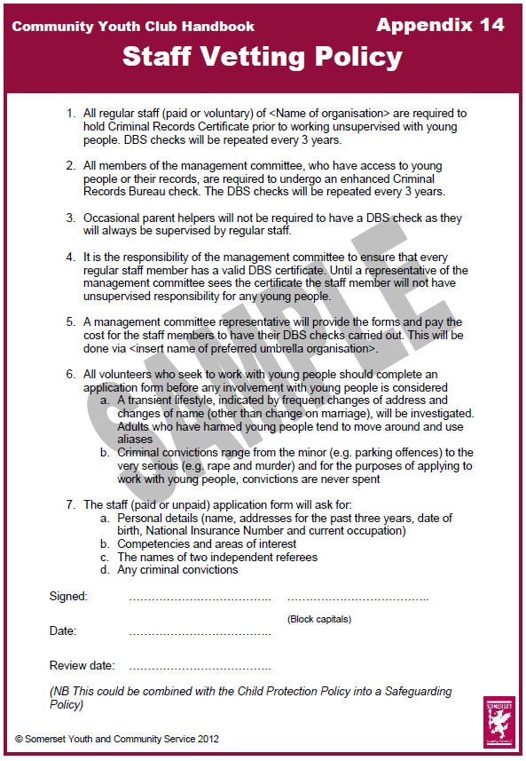

**Appointing Safeguarding Officers**

The next step is to appoint at least one Safeguarding Officer.

Choose a respected and committed person for the role (it’s best to have two). The person then becomes a point of contact for staff, volunteers, parents and other organisations such as Children’s Social Care or the police if a problem relating to a child or young person arises.

The Safeguarding Officers’ names should be displayed prominently on your paperwork and at the club.

Safeguarding Officers should ideally undertake the Level 2 Introduction to Child Protection Training (visit <http://sscb.safeguardingsomerset.org.uk/training/> to check availability). If this is not possible, SYCS can deliver the 3½ hour basic course to Somerset clubs running universal open-door provision for 11 -19 year olds.

The role of the safeguarding officer(s) is to be the gatherer of concerns about young people who attend the club. Staff and volunteers must report any concerns, and the Safeguarding Officer will decide whether or not to contact Somerset Direct, or take another form of action.

Being a Safeguarding Officer shouldn’t take up too much time, but it is an important role in a youth club. The person who takes this role should still be able to devote most of their energies to the club itself.

**Recruiting Safely**

All staff and volunteers should be told that child protection procedures will be used in any recruitment process. Your staff vetting policy should set these out. Good practice includes:

* Having a standard application form* which all staff and volunteers complete. It should ask for any criminal convictions or pending cases
* Have a standard reference form* which specifically asks about the applicant’s fitness to work with children and young people
* Requesting at least two referees, one of whom should have knowledge of the applicant’s experience with children and young people
* Asking applicants to sign a declaration* that there is no reason why they shouldn’t work with children
* Asking each new member of staff or volunteer to sign a code of conduct and to give them a staff support sheet* that defines their role and their support.
* All staff, volunteers and management committee members have a DBS check
* Make sure applicants are interviewed by at least two members of your organisation
* Ask for formal proof of identity, such as a driving licence or passport
* Do not let anyone work at the club until all of the above has been completed

*SYCS has samples of all these forms (apart from DBS) and can email them to the management committee if requested. Samples are overleaf:

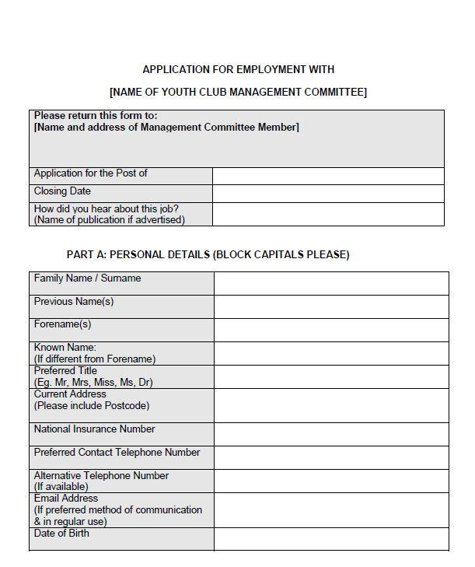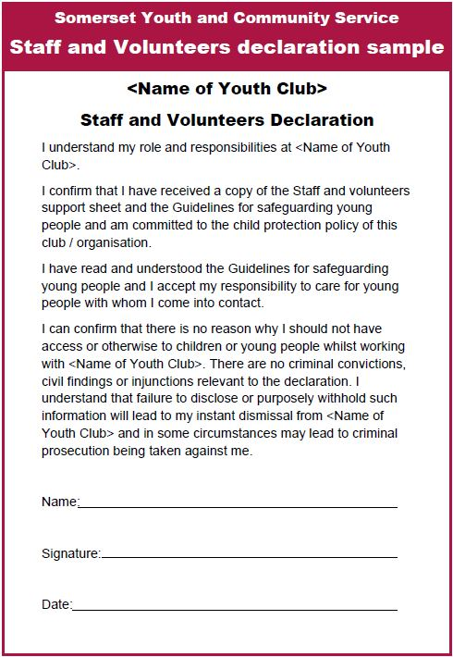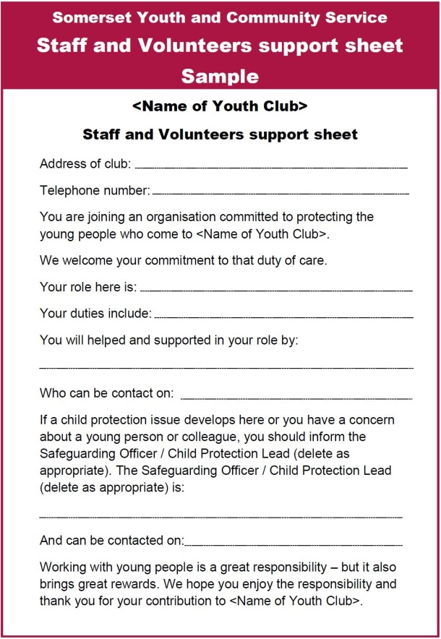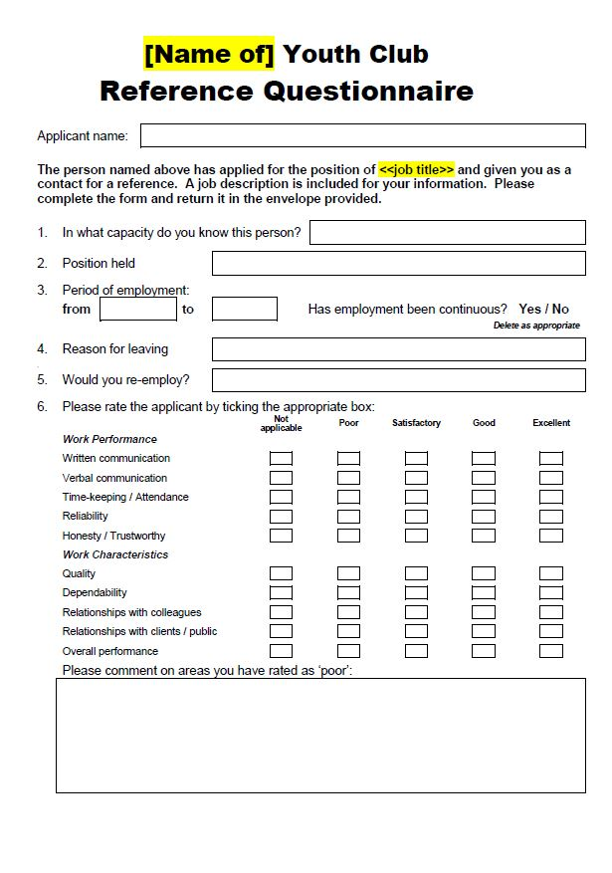

Do not reply solely on DBS clearance as proof of a person’s suitability to work with children and young people. The majority of abusers have never been prosecuted and a DBS certificate is a bit like an MOT; only really valid on the day it was issued.

Having all these other things in place, and adhered to, will help to put off anyone who wants to join your organisation in order to groom children or young people.

The next thing is to make sure everyone in your organisation knows how you ensure children and young people are safe.

**Getting the message across to:**

* **Staff and volunteers**

Once you have policies and paperwork in place, and have appointed your safeguarding officers, it’s time to make sure the rest of your organisation knows and understand it.

* If possible, get SYCS to deliver Basic Child Protection Training to all your staff and volunteers. It’s accredited by Somerset Safeguarding Children’s Board and is free to clubs affiliated to SYCS
* Provide copies of the Guidelines for Safeguarding Young People (as available from SYCS)
* Have a staff meeting and go through your club’s code of conduct (also available from SYCS) to ensure everyone understands.
* Ask existing staff and volunteers to sign the declaration and code of conduct (if they haven’t already done so).
* 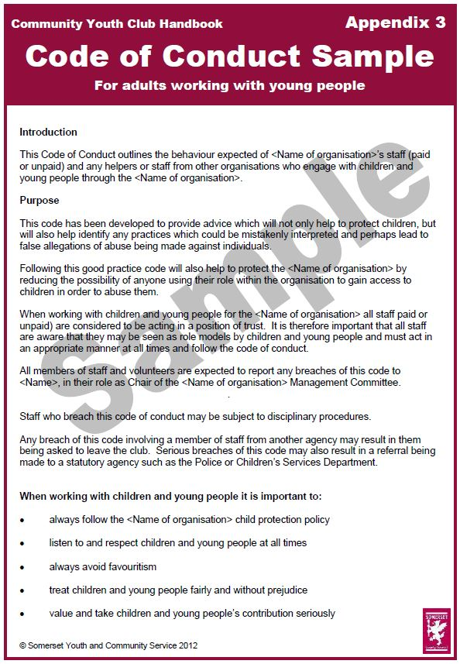Display your equalities and child protection policy. It’s good to also display the poster below (also available from SYCS).

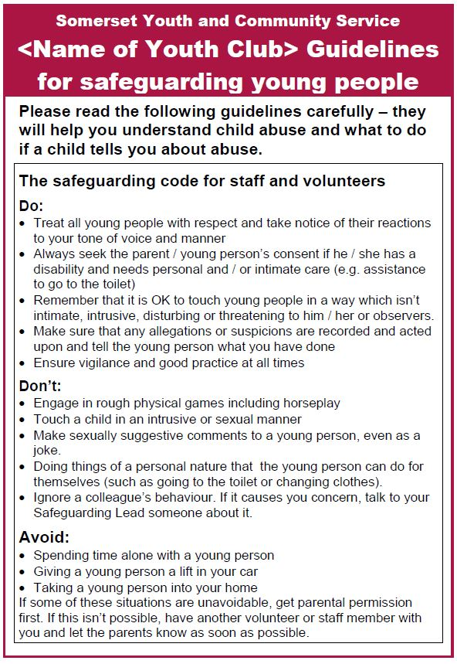

**Parents and carers**

It is helpful and reassuring to explain your organisation’s approach to safeguarding and protecting children to parents and carers, as well as introducing the child protection officer. How you do this is up to you. You could have a parents meeting, or talk about it when you see them.

It would be good to provide the following documents to parents when you get the consent form for their son / daughter

* A letter explaining your commitment to safeguarding and where they can get the child protection, staff vetting and equalities polices
* Contact numbers for the person in charge of the club when it’s open, the Chair of the Management Committee and the Child Protection officer
* A parent or carers’ guide to child protection. Available from SYCS, this tells parents:
* What child abuse is and what to look for
* How to keep their children safe
* How to check out the groups their children attend
* What to do if they suspect abuse is happening
* What to do if their child discloses that they have been or are being abused

The guide can be altered to carry your club logo and there is space on the leaflet to put club contact details.

In case they have questions or want more information, make sure they can talk to the child protection officer.

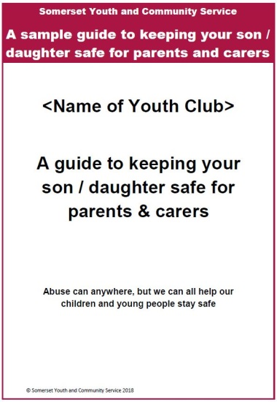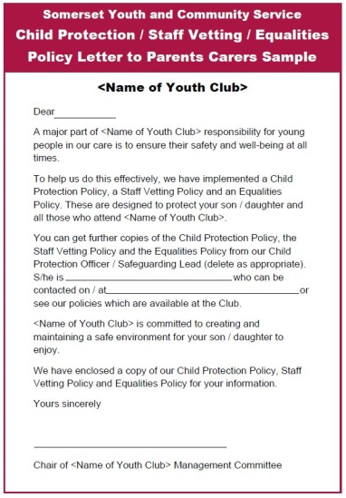

**Children and young people**

It’s important that you get the message across to young people who attend your club too. Consider doing the following

* When a young person first comes to club, as part of their ‘induction,’ explain (in an age appropriate manner) that:
  + the club has a Child Protection Policy and a Child Protection Officer. Tell them that its OK to talk to someone at the club about anything that’s happening to them that makes them uncomfortable
  + Some things can be kept confidential and some can’t. SYCS has a poster that explains this and the wording can be used in this conversation too.
* Include some young people’s safety activities in your programme – go to [www.somersetyouth.co.uk](http://www.somersetyouth.co.uk) and click on ‘youth work resources’, then ‘session plans and resources’ and scroll down to the safeguarding section.
* Or, do a poster creation activity asking young people for their top tips for safety. Below is a sample of what young people might produce (or you could turn this into a simple advice sheet to give out and discuss with young people).
* Give out a copy of the ‘Young Person’s Guide to Keeping Children Safe’ from the office of the Children’s Commissioner. SYCS can provide this for you too.

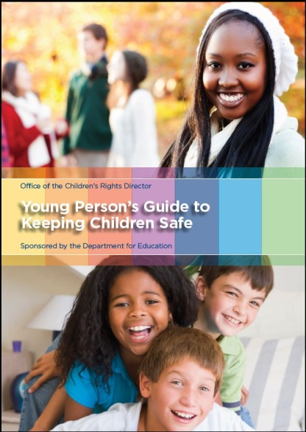

**Safety advice for young people:**

* Don’t speak to adults you’re uncomfortable with. Just walk away
* Don’t go up to a strange car for any reason, even to give directions. Keep your distance so you can run away easily
* If something you don’t like happens, tell your parents, youth club staff or a teacher you trust. Even if you’ve broken a rule, it will be sorted out
* Shout and run away if someone frightens you or follows you. Go to places where there are people.
* Remember – keeping safe is the most important thing. You can break rules to keep safe.
* Any more that young people want to add…

**What is child abuse?**

Most people want children and young people to be safe, but there are some who wish them harm. These people can be in the family, friends of the family, at school or at clubs and activities that young people attend.

In most cases children are abused in the family home or by someone known to the family, but not always.

Any adult (aged over 18) who works with a child or young person is in a ‘position of trust’ and it is an offence for them to have any sexual contact with that young person, whether or not the young person feels that they have given consent.

You should always pay attention to an adult who doesn’t follow the organisation’s policies, procedures or code of conduct. For example, giving gifts, favours or money, taking them on outings or looking for ways to be alone with them.

There are four main categories of abuse:

**Sexual Abuse**

Sexual offenders come from all levels of society and all backgrounds. They may try to take up positions that give them access to children and young people (e.g. coach, teacher, teaching assistant, youth worker, carer). *Both boys and girls can be sexually abused in the following ways:*

* Full sexual intercourse, masturbation, oral sex and groping
* Showing young people pornographic images
* Asking or encouraging young people to take part in the creation of images (taking photos and selfies)
* Grooming in preparation for abuse

*What to look for:*

* Unexplained or untreated bruising or injuries
* Stomach pains
* Discomfort when walking
* Unexplained sources of money
* Inappropriate drawings, language or behaviour
* Aggressive, withdrawn behaviour or fear of one person
* Unaccounted-for presents or money

**Grooming (preparation for sexual abuse)**

The process by which a young person is prepared for sexual abuse is called grooming and this can happen over days, months or years. Parents may be groomed too, so that the abuser can get easy access to the child or young person.

Grooming can be played out by befriending, followed by testing of a young person’s boundaries. A young person with good self-esteem, confidence and awareness may be able to protect themselves from this process. Boundaries can be tested by a whole range of techniques such as kissing, touching and conversations – all of which can lead to inappropriate behaviour.

Showing pornographic material is another way of testing boundaries and grooming them for abuse.

Children and young people can be at risk from the people who work with them or are in positions of trust.

It is an offence for anyone over the age of 18 to communicate with an under-16 on at least two occasions (including by phone or internet), and then travel to meet them with the intention of committing any form of sexual abuse.

**Physical Abuse**

Physical abuse can be through hitting, shaking, poisoning, biting or burning in ways which cause injury. In certain situations, abuse may occur when the nature and intensity of training exceeds the capacity of the young person’s body.

Physical abuse includes giving young people alcohol or drugs and can take the form of peer to peer bullying.

*What to look for:*

* Unexplained or untreated injuries
* Injuries on unlikely parts of the body
* Cigarette burns, bite or belt marks, scalds
* Fear of going home, receiving medical advice or parents being contacted
* Flinching when touched
* Refusal to discuss injury, covering arms or legs
* Frightened or withdrawn

**Neglect**

Where adults:

* Fail to meet a young person’s basic needs (e.g. food, warmth and clothing)
* Constantly and inappropriately leave a young person alone or unsupervised
* Fail or refuse to give love, affection or attention
* Fail to prevent harm – for example, missed doctor or dentist appointments or allowing someone else to abuse a child or young person

Neglect might also occur during organised activities if young people are placed in an unsafe environment, are exposed to extreme weather conditions or are at unreasonable risk of being injured.

*What to look for:*

• Poor personal hygiene

• Constantly hungry

• Inappropriate clothing, dishevelled appearance

• Constantly tired

• Lonely, no friends

• Underweight

• No parental support or interest

**Emotional abuse**

This includes persistent subjection of a child or young person to emotional ill-treatment, bullying or deliberate rejection. It may also affect young people who live in households where there is domestic abuse or inappropriate parental expectation. It also includes:

• Persistent lack of love and affection

• Frequently shouting at young people

• Taunting young people

• Over-protection leading to poor social skills

Other behaviour is categorised under headings such as belittling, humiliating, shouting, scapegoating, rejecting, isolating, threatening and ignoring

*What to look for:*

• Over-reaction to mistakes

• Sudden speech disorders

• Extremes of emotion

• Self-harm

**Other things to be aware of:**

**Child Sexual Exploitation**

* Children and young people are forced or manipulated into sexual activity in exchange for something – e.g. money, gifts, drugs and alcohol, accommodation, affection, status
* It may be seen by the young person as consensual, but its based on power imbalance and limiting the victim’s options

*What to look for*

* Staying out late and no-one knowing where they are
* Going missing for short periods or days at a time
* Starting to miss school, college or work
* Distancing themselves from family and friends
* Changes in behaviour
* Increase in drug or alcohol use
* Change in academic performance
* Being secretive about where they’re going or who with
* Change in appearance
* Sexualised behaviour
* Being collected by a stranger
* Having new things (e.g. shoes, clothes and gadgets) they can’t explain

**Child Exploitation (also known as ‘County Lines)**

* This is where gangs and organised crime networks exploit children to sell drugs.
* Often these children are made to travel across counties, and they use dedicated mobile phone ‘lines’ to supply drugs.

‘What to look for’ is similar to that mentioned in ‘Child Sexual Exploitation’

**Domestic Abuse**

* Can be physical, emotional, psychological, verbal, financial or sexual
* Domestic abuse happens between adults, but affects the child
* Witnessing domestic abuse is recognised as ‘significant harm’ and can be emotional abuse
* 62% of children and young people in households where domestic violence happens are also harmed
* The perpetrator may also be physically or sexually abusive to the child or young person
* Being involved can adversely affect the ability to parent

**Online Abuse**

Text, email and all sorts of social media used against young people for:

* Bullying
* Sexual activity
* Grooming in preparation for abuse

For most young people, it’s not an option to switch off their phone

**Modern Slavery**

The most commonly seen forms of this are sexual, labour and domestic servitude. About 33% of cases involve under-18s.

**Female Genital Mutilation**

* A procedure where the female genital organs are injured or changed and there is no medical reason for it.
* It’s frequently a very traumatic, painful and violent act that can cause long term health problems
* It can be carried out shortly after birth, during childhood or adolescence, just before marriage or during a woman’s first pregnancy
* It is illegal to subject a girl or woman to FGM or transport them so it can happen
* 10,000 girls under 15, and 125,000 women, are living with the consequences in the UK
* It can be done for cultural reasons (hygiene, purity and control) where families believe it to be beneficial

**If you’re concerned, what should you do?**

It’s **not** your responsibility to decide whether or not a child or young person has been abused. It **is** your responsibility to act on any concerns.

* Record your concerns in detail, and as soon as you can. Also record observations you can make – about injuries, behaviour, how the child or young person looked etc.
* You must keep this confidential, and not challenge or inform the abuser or anyone else, other than your club’s Safeguarding Officer and any other professionals.
* Speak to your Safeguarding lead.
* The Safeguarding lead should contact Children’s Social Care via Somerset Direct (0300 123 2224) or the police about it. If the disclosure concerns someone in your organisation, ring Somerset Direct and ask to speak to the Local Authority Designated Officer, who specialises in this.
* Get support for yourself

**What do I do if a young person tells me they’ve been abused?**

* Most importantly, stay calm and listen to them
* Believe them, listen attentively and let the young person know that it was right to tell someone about their worries.
* Don’t react in a way which will upset the young person. Don’t tell them off if the abuse has occurred because they disobeyed you.
* Let them say as little or as much as they want. Don’t try to get more information than they are willing to give. You must not investigate or examine the child or young person – leave this to the professionals.
* Treat any allegation or disclosure seriously and always take action. **Doing nothing is not an option.**
* Explain that you have to tell someone about the abuse. Tell them what you’re going to do, who you will tell and why
* Record what the young person has said in detail, and as soon as you can. Don’t interpret what they’ve said, write down exactly what they said and record any observations you can make – injuries, how the young person looked etc.
* You must keep this confidential, and not challenge or inform the abuser or anyone else, other than your club’s Safeguarding Officer and any other professionals.
* The Safeguarding lead should contact Children’s Social Care via Somerset Direct (0300 123 2224) or the police about it, unless the disclosure concerns someone in your organisation. If it does, ring Somerset Direct (0300 123 2224) and ask to speak to the Local Authority Designated Officer.
* Get support for yourself

Don’t worry that you may make things worse by reporting your concerns – few things are worse than allowing serious child abuse to continue. Many children and young people are devastated by the experience of abuse and, in the most serious cases, may be seriously harmed or have their lives threatened.

If you suspect a child has been abused you will probably be very upset and, if abused by someone you trust, may feel anger towards someone you trusted. DO NOT confront the abuser; seek help and report your concerns – there are organisations to help you.

**Remember** – these guidelines are meant to help you feel comfortable about young people’s safety. Most adults are not abusers, so you need not be frightened, or frighten young people, unduly.

By following the advice in this booklet, you’ll help protect young people and help them protect themselves – developing independence and self-confidence.

It’s important to keep a sense of perspective about child abuse. Remember:

* Most adults will never hurt a child
* Children and young people should be allowed to become independent and learn to look after themselves
* There’s no need to wrap them in cotton wool

**For the documents mentioned in this guide, please contact:**

Somerset Youth & Community Service

The Hollies, South Street, Taunton, TA1 3AG

01823 357552

youthservice@somerset.gov.uk

www.somersetyouth.co.uk

